**MILESTONE 4**

- What and Why CSS

- SASS and SCSS

- Syntax

- Basic Properties

- Height, Width

- Margins, Paddings, Border

- Background

- Text, Font, Image

- Box Model, Display, Flex

1. **What and why CSS**

* What is CSS - Cascading Style Sheets (CSS) is a stylesheet language used to describe presentation of a document written in HTML or XML.
* Why CSS – CSS is used to define styles of our web pages, including design, layout, variation, display for different devices and screen size**.**

1. **SASS and SCSS**

* SCSS and SASS are syntaxes of SASS pre-processor with advanced CSS feature.
* Extension of SCSS is .scss and SASS is .sass
* SCSS
  + Sassy CSS offers more CSS-like syntax.
  + It includes variables, nesting, mixins, inheritance with standard CSS.
  + Ex - $bgcolor, $textcolor etc for styling. They are used to set background color, color etc
  + Mixins – create reusable chunk of styles, to avoid repetitive code.
    - Ex - @mixin important-text {

color: red;

font-size: 25px;

font-weight: bold;

border: 1px solid blue; }

.danger {

@include important-text;

background-color: green;

}

* SASS
  + Syntactically Awesome Stylesheets is a CSS pre-processor that extends CSS with features
* Difference between SCSS and SASS
  + SCSS – It has braces and semicolons
  + SASS – It is based on indentations without braces or semicolon.
* SASS reduces repetition of CSS and saves time.
* EX - $primary_1: #a2b9bc;

.header {

background-color: $primary_1;

}

* Here if we want to change the HEX value, it can be changed in one place instead of changing it everywhere like in CSS.
* Browser doesn’t understand SASS code. So transpiler converts SASS code to css. This process is called transpilling.

1. **HTML, CSS Syntax**

* CSS Syntax –

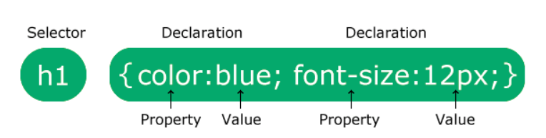

* HTML Syntax – refers to set of rules and syntax to create a valid HTML document.
  1. It should have opening<> and closing tag</>.
  2. Every HTML documentation should begin with <!DOCTYPE html> declaration.

1. **Basic properties**
   1. **Height, width**
      1. Height and width properties are used to set height and width of an element.
      2. Max-width : o set the maximum width of an element. It has specified values like px, cm, %
      3. Min-width: sets minimum width of an element.
      4. Max-height: sets maximum height of an element.
      5. Min-height: sets minimum height of an element.
   2. **Margin**
      1. Margin is used to create space around elements, outside any defined borders.
         1. Margin-top
         2. Margin-right
         3. Margin-bottom
         4. Margin-left
      2. It can have following values – auto, length (px, pt, cm), %, inherit (margin should be inherited from parent element).
      3. It is a shorthand property. Ex: margin: 20px 21px 22px 23px –
         1. 20px – top margin
         2. 21px – right margin
         3. 22px – bottom margin
         4. 23px – left mrgin
      4. If it has 3 values, Ex: margin: 20px 21px 22px,
         1. 20px – top margin
         2. 21px – right and left margin
         3. 22px – bottom margin
      5. If margin: 25px 50px
         1. 1. 25px – top and bottom margin
         2. 50px – right and left margin
      6. It margin: 25px, then all four sides have 25px
      7. By using **margin: auto**, it horizontally aligns to centre within its container.
      8. By using **margin: inherit,** It inherits the property from the property.
   3. **Padding**
      1. Padding is used to create space around an element, inside any defined borders.
      2. It has same properties as margin, like adding-top, padding-right, padding-bottom, padding-left.
      3. It is also a short-hand property.
   4. **Background**
      1. It is a short-hand property. Ex: background: lightblue url("img_tree.gif") no-repeat fixed center; }
         1. Above example comprises of background-color, background-image, background-position, background-size, background-reeat, background-origin, background-clip, background-attachment.
         2. Its values can be left top, left center, left bottom, right top, right center, right bottom, center top, center bottom.
         3. It can also be x% y% - where 1st value is horizontal position, 2nd value is vertical position. Top left corner is 0% 0%, right bottom corner is 100% 100%. Default value is 0% 0%
         4. It can also be mentioned as xpos ypos.
      2. Background-position-x property sets position of background image on x-axis. Same goes for background-position-y
      3. Background-repeat : It says how the image is to be repeated. It has values like repeat, repeat-x, repeat-y, no-repeat, space, initial, inherit.
      4. Background-size. It has values like auto, cover, contain, initial, inherit. It can also have 2 values, where 1st value represents width of image. 2nd value represents height of the image.
      5. Box-shadow: **EX:** box-shadow: 0 0 2px 1px rgba(0, 140, 186, 0.5);
         1. 1st 0 – horizontal offset
         2. 2nd 0 – vertical offset
         3. 2px – blur radius
         4. 1px – spread radius
   5. **Font**
      1. Choosing right font has a huge impact on how readers experience a website.
      2. Serif – small stroke at edges.
      3. Sans-serif: have clean lines.
      4. Font-family has **fallback** system. So start with font-family what we want, end with generic family. If starting font is not available, then generic font will be picked by the browser.
   6. **Text**
      1. Text color is specified by color: red.
      2. Background colour is specified by background-color: red
      3. Text-align is used to set horizontal alignment of a text.
         1. It has 4 values – center, left, right, justify
         2. Text-align last: specifies how to align last line of a text.
      4. Text-decoration: used to add decoration to text.
      5. It is also one of the shorthand property.
         1. Ex: text-decoration: underline red double 5px
            1. Text-decoration-line: underline (req)
            2. Text-decoration-color: red (optional)
            3. Text-decoration-style: double (optional)
            4. Text-decoration-thickness: 5px (optional)
      6. Text-transform: uppercase/ lowercase/ capitalize (capitalizes 1st letter of the word).
      7. Text spacing
         1. *Text-indent:* used to specify indentation of the first line of a text. **EX:** text-indent: 10px
         2. *Letter-spacing*: used to specify space between characters in a text. **Ex**: letter-spacing: 5px
         3. *Line-height:* used to specify the space between lines. **EX:** line-height: 0.8
         4. Word-spacing: used to specify space between words in a text. **EX:** word-spacing: 10px
      8. White-space: specifies how white space inside an element is handled. **EX:** white-space: no-wrap (doesn’t goes to next line)
      9. Text-shadow: adds shadow to text **EX:** text-shadow: 2px 3px black
         1. Here 2px – adds horizontal shadow
         2. 3px – adds vertical shadow
         3. Black – color of shadow

More than 1 property can be given.

* 1. **Images**
     1. Border-radius: 50% 🡪 creates circled image
     2. Border-radius: 10px 🡪 creates rounded-image
     3. Transparent images can be created using **opacity.** It has value between 0.0-1.0
     4. **Filter** property is used to add sharp/ saturation to the image.
        1. **EX:** {filter: blur(4px);}

{filter: brightness(250%);}

{filter: contrast(180%);}

{filter: grayscale(100%);}

{filter: hue-rotate(180deg);}

{filter: invert(100%);}

{filter: opacity(50%);}

{filter: saturate(7);}

{filter: sepia(100%);}

{filter: drop-shadow(8px 8px 10px green);}

1. **CSS Box Model**

* It is used to design and layout.
* It is a box that wraps around every HTML element. It consists of content, padding, borders, margin. Below diagram refers to box model

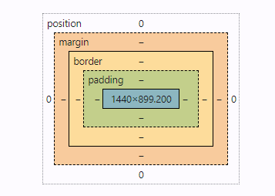

1. **Display**
   1. Display has many values like
      1. Inline – it will accept margin, padding. But it will not accept height, width. Margin and padding will push elements horizontally and not vertically. It doesn’t break the flow of text.
      2. Inline-block – Same as inline but here it is possible to set width, height.
      3. Block - A block element always starts on a new line and takes up the full width available, from left to right, unless you specify a width.
      4. Flex – easy to arrange and align items inside a container. It helps to place elements side by side, space them out, center them, organize them into rows and columns
         1. It contains additional property: **justify-content (flex/ grid)**
            1. Center: Aligns flex-items at center of the container.
            2. Flex-start: Aligns flex-items at starting of the container.
            3. Flex-end: Aligns flex-items at end of the container.
            4. Space-between: Aligns flex-items with space between the lines.
            5. Space-around: Aligns flex-items with space before, between, after the lines.
            6. Space-evenly: Aligns flex-items with space evenly the lines.
         2. **Align-items:** used to align items inside flex/ grid

align-items: stretch;

align-items: center;

align-items: flex-start;

align-items: flex-end;

align-items: baseline;

* + 1. Grid - Defines the element as a grid container and establishes a new grid formatting context for its contents.
       1. Grid-template-columns, grid-template-rows: defines columns and rows of grid with space-separated list of values.
          1. **EX**:

.container {

**grid-template-columns:** [first] 40px [line2] 50px [line3] auto [col4-start] 50px [five] 40px [end];

**grid-template-rows:** [row1-start] 25% [row1-end] 100px [third-line] auto [last-line];

}

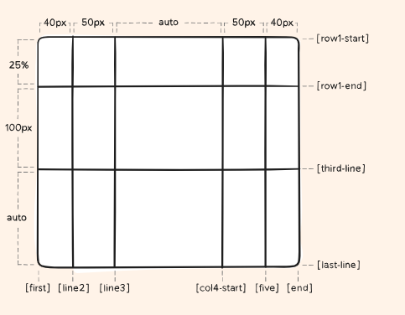

* + - * 1. Grid-template-areas work with respect to grid-areas
        2. Column-gap, row-gap: specifies size of grid lines

column-gap: 10px;

row-gap: 15px;

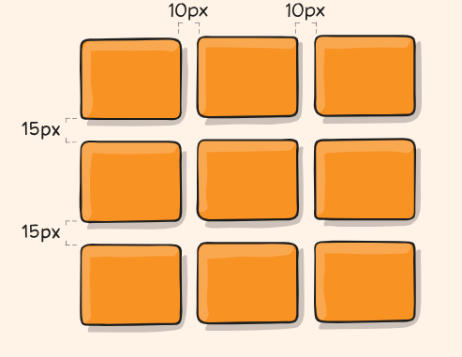

* + - * 1. Gap is a short-hand property for row-gap, column-gap

gap: 15px 10px; 🡪 15px (row gap); 10px (col gap)

1. **Flex:**
   1. Flex-grow: it controls how a flex item should stretch more than others.
      1. .box1{

Flex-grow: 1;}

.box2{

Flex-grow: 2;}

Here box2 will have more space than box1

* 1. Flex-shrink: tells how much a box should shrink, when space gets tight. If we want one box to shrink more than others, big number has to be given
  2. Flex-basis: defines initial size of a flex item before it starts growing or shrinking
  3. Flex is a shorthand property of flex-grow, flex-shrink, flex-basis.

Syntax: flex: *flex-grow* *flex-shrink* *flex-basis* |auto|initial|inherit;

* 1. Flex-flow is a shorthand property of flex-direction, flex-wrap.
  2. Flex-direction: used to specify how flex-items are displayed. Its vales are
     1. Row, row-reverse, column, column-reverse, initial, inherit.
  3. Flex-wrap: controls where the flex items should stay in one line or wrap into many lines if there is not enough space in container.
     1. Flex-wrap: wrap – elements will move into new row when there’s not any enough space in that row.
     2. Flex-wrap: nowrap – default value. Specifies that the flexible items will not wrap.
     3. Flex-wrap: wrap-reverse – items will wrap, if needed in reverse order.
* Justify-content: to align items in a single line
* Align-content: Controls the spacing and alignment of lines when items wrap
* Justify-items: Aligns items horizontally within their individual grid cells in a Grid container. Applies to a single cell/ item
* Align-items: Aligns items vertically within the container in Flexbox or Grid layouts. Applies to entire container.
* Justify- self: Aligns an individual grid item horizontally within its grid area.

**HTML**

<div class="grid-container">

<div class="item1">1</div>

<div class="item2">2</div>

<div class="item3">3</div>

</div>

**CSS**

.grid-container { display: grid;

grid-template-columns: 100%

} .item1 { justify-self: start; }

.item2 {

justify-self: center; }

.item3 {

justify-self: end; }

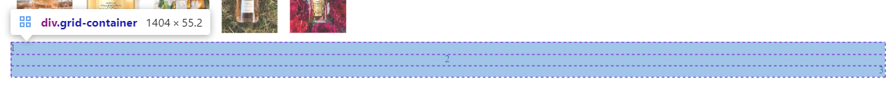

* Align-self: Aligns an individual flex or grid item vertically (in a row) or horizontally (in a column) within its container, overriding the container’s align-items setting.